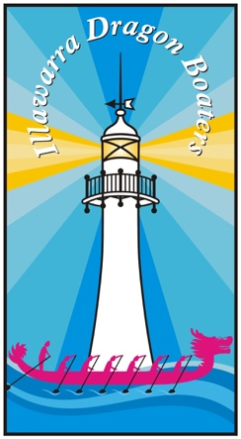
ILLAWARRA DRAGON BOAT CLUB INC.

MEMBERS CODE OF CONDUCT

In addition to Dragon Boats NSW General Code of Conduct all members of Illawarra Dragon Boat Club Inc. will be required to adhere to the following requirements in regard to your conduct during any activity held by Illawarra Dragon Boat Club Inc. or sanctioned by Dragon Boats NSW Inc. or an affiliated club and in your role as participant in any activity held under the auspices of Illawarra Dragon Boat Club Inc, Dragon Boats NSW Inc. or an affiliated Club.

- Operate within the rules and spirit of the sport, promoting fair play over winning at any cost

- Encourage and support opportunities for people to learn appropriate behaviours and skills

- Support opportunities for participation in all aspects of the sport.

- Display control and courtesy to all involved with the sport.

- Respect the rights and worth of every person regardless of their gender, ability, cultural background or religion.

- Respect the decisions of officials, coaches, and administrators in the conduct of the sport.

- Wherever practicable avoid unaccompanied and unobserved one-on-one activity (when in supervisory capacity or where a power imbalance will exist) with people under the age of 18.

- Adopt appropriate and responsible behaviour in all interactions.

- Adopt responsible behaviour in relation to alcohol and other drugs.

- Act with integrity, and accept responsibility for your decisions and actions.

- Ensure your decisions and actions contribute to a safe environment.

- Ensure your decisions and actions contribute to a harassment free environment.

- Do not tolerate harmful or abusive behaviours. Do not use language that is offensive, abusive or disrespectful to others.

I acknowledge I have read the above and understand the Members Code of Conduct as an active member of the Illawarra Dragon Boat Club Inc.

Members Name ………………………………………

Signature …………………………………………….. Date ………………………

